]Title Page:

**Title:** Contributions of human activities to suspended sediment yield during storm events from a small watershed in American Samoa.

**First Author: Alex T. Messinaa,*, amessina@rohan.sdsu.edu**

**Second Author: Trent W. Biggsa, tbiggs@mail.sdsu.edu**

**a Department of Geography, San Diego State University, 5500 Campanile Dr., San Diego, CA, 92182-4493 USA.**

**\*Corresponding author. Present address: Department of Geography, San Diego State University, 5500 Campanile Dr. San Diego, CA 92182-4493, USA. Tel: +1 714 915 3360. Email address: amessina@rohan.sdsu.edu**

# **Abstract**

Suspended sediment yield (SSY) was measured from both undisturbed and human-disturbed portions of a small, tropical watershed that drains to a priority coral reef experiencing sedimentation stress. Data on precipitation, discharge, turbidity, and suspended sediment concentration were collected over three field campaigns and several periods of continuous monitoring of stream stage and turbidity from January, 2012, to March, 2014. Suspended Sediment Concentrations (SSC) during base- and stormflows were significantly higher adjacent to an open-pit aggregate quarry, indicating the quarry is a key sediment source requiring sediment discharge mitigation. Comparison of storm event SSY from the upper, undisturbed watershed, and the lower, human-disturbed watershed showed the Lower watershed accounted for >80% of total SSY on average, and human activities have increased total sediment loading to the coast by ~200%. Four predictors of event SSY including Total Event Precipitation, Event Erosivity Index, Total Event Discharge, and Event Maximum Discharge, were assessed using Pearson’s and Spearman’s correlation coefficients. SSY from both the undisturbed and disturbed watersheds had the highest correlation with event maximum discharge (Qmax) (Pearson’s R=0.88 and 0.86 respectively). Power Law rating curves had higher r2 values than Linear functions, and were selected as the best model of event-based SSY. Area-normalized SSY-Qmax models compared favorably with results from other small, mountainous watersheds, and showed sediment loading from Faga’alu is significantly increased above natural levels due to human disturbance.

# **Introduction**

## **Motivation**

Many coral reefs around the world are impacted by land-based sediment generated by anthropogenic watershed disturbance. Dams, river channelization, river bank armoring and urbanization can decrease suspended sediment loading (Draut et al., 2009). Conversely, land cover change due to industry, agriculture, deforestation, roads, and urbanization can alter the timing, composition, and mass of sediment loads to coral reefs, causing enhanced sedimentation on corals near the outlets of impacted watersheds (Syvitski et al., 2005) Impacts of these land cover changes are exacerbated on tropical islands characterized by high rainfall, extreme weather events, steep slopes, highly erodible soils, and naturally dense vegetation. Where soils are covered by sparse vegetation, land clearing alters the fraction of exposed soil much less than where soils are naturally covered by canopy forest and thick ground cover like in American Samoa. Sediment can bond with and transport other pollutants, attenuates light for photosynthesis, prevents larval recruitment, and stresses or smothers the coral organisms (Fabricius, 2005). Deposited sediment can be resuspended due to wave action and reworked over the reef, causing persistent negative effects to ecosystem health or distributing impacts to larger areas (Presto et al., 2006).

Successful reduction of sedimentation threats to coral reefs requires first identifying and quantifying the land-based sources of sediment to focus management efforts and design mitigation measures. Monitoring suspended sediment yield (SSY) from remote streams that are dominated by infrequent, high magnitude storm events is resource intensive and requires technical skills unavailable to local managers. Environmental managers require simple yet effective methods to identify major sediment sources, quantify sediment yield from key sources, and establish objective metrics of success such as reduced sediment loading to reefs. Currently, there is no generic procedure for accurate prediction of SSY in small, mountainous catchments to meet local management needs. Furthermore, reliable parameterization of models that predict SSY from small, mountainous catchments is a major need for further incorporation into models applied at the regional scale, where societal needs are greatest (Duvert et al., 2012).

Several studies have found significant correlation between event SSY and various precipitation and discharge variables, but the best correlation has consistently been with maximum event discharge (Qmax). Several researchers have hypothesized Qmax shows high correlation with SSY because Qmax is an integrator of the whole hydrological response of a given watershed to a given storm event. Rankl (2004) argued that the largest variability in event SSY is the result of variability in rainstorm energy. Since Qmax depends on the intensity and volume of rainfall, he concluded that a relation should exist between SSY and Qmax as both are driven by rainfall energy. Li et al. (2004) proposed the use of a runoff erosivity index instead of traditional rainfall erosivity for the prediction of SSY, hypothesizing that discharge characteristics better integrate the watershed response than precipitation variables. Duvert et al. (2012) hypothesized Qmax is a meaningful variable because it relates to both the sediment production on the hillslope and in the channel, and the transfer functions of sediment dynamics. They argue where runoff is produced by rainfall excess, Qmax is a function of rainfall intensity and the duration of high intensity (rather than volume), and where runoff is produced by saturation excess overland flow, Qmax depends on the hydrological processes occurring from hillslopes to the river channel, which are controlled by the soil antecedent wetness conditions and by the water table dynamics. Duvert et al. (2012) argued that by being responsive to these important hydrological processes in diverse environments, Qmax is a good predictor variable of event SSY. High correlation between event SSY and Qmax has been found in semi-arid, temperate, and sub-humid watersheds in Arizona, Wyoming, Italy, and New Zealand, but this approach has not been attempted for tropical watersheds on volcanic islands.

Duvert et al. (2012) also fit regression lines using a correction factor to correct for potential negative bias introduced by log-transforming the data (linear with bias correction) (Sprugel, 1983), and a nonlinear least squares regression method (nonlinear model) (Asselman, 2000). A coefficient of determination was modified to incorporate variable sample sizes, and calculated for each regression to select the best model fit. The nonlinear models were more accurate overall (higher coefficient of determination), especially at fitting the highest SSY values, but overestimated SSY at low values, where linear models were more accurate.

A main objective of this study was to determine how much sediment loading to Faga’alu Bay has been increased by human disturbance, and how the increase varies by storm size. To compare event SSY from different watersheds (Duvert et al., 2012; Fahey et al., 2003; Hicks, 1990), or subwatersheds (Basher et al., 2011), the most common method is to normalize SSY by watershed area to calculate the “specific sediment yield” (mass/area) (Milliman and Syvitski, 1992). To compare the SSY-Qmax relationship from different watersheds, Qmax can be used without alteration (Basher et al., 2011), normalized by event mean discharge (Basher et al., 2011), or normalized by area (Duvert et al., 2012). When normalized by area, the SSY-Qmax relationship measured upstream and downstream would be the same under natural conditions (assuming the watershed is homogenous). Upward displacement of the SSY-Qmax rating curve is attributed to increased SSY from human disturbance. If area-normalized event SSY rating curves converge at higher Qmax values, it indicates a diminishing relative increase from human disturbance for large storms.

This paper describes a research project to quantify SSY from undisturbed and human-disturbed portions of a small watershed in American Samoa, and to develop a simple model of sediment loading based on storm event characteristics. This simple model is developed for managers from NOAA Coral Reef Conservation Program (CRCP) and the US Coral Reef Task Force (USCRTF) to provide baselines of natural and anthropogenic SSY to priority coral reefs, prior to an extensive watershed management initiative at the study site.

## Research Questions

The research questions are:

1. **How has human disturbance altered the sediment loading to Faga’alu Bay?**

This will be answered by:

* 1. Comparing SSC during base- and stormflow conditions, and Q-SSC relationships measured below the undisturbed and disturbed watersheds.
  2. Comparing SSY rating curves from the undisturbed and disturbed watersheds.
  3. Calculating the percent of total sediment load contributed by the forested upper watershed and the human-disturbed lower watershed.

*Hypothesis*: Human land use, mainly by open-pit aggregate mining, has significantly increased fine sediment loading above the undisturbed baseline.

1. **How does the relative increase in sediment yield from human-disturbed areas vary by storm size?**

This will be answered using the SSY rating curves: if the rating curves from upstream and downstream intersect at high discharge it indicates diminishing influence of human impacts on SSY.

*Hypothesis:* For small and medium-sized storm events, human land use has significantly increased total suspended sediment loading; but for large events, total sediment loading is dominated by natural sediment loading.

1. **Which is the best predictor of event-based SSY at each location?**

This will be answered by Pearson’s correlation and Spearman’s rank coefficients calculated for four predictors and event sediment yield. The best predictor will have the highest Pearson’s correlation and Spearman’s rank correlation coefficients.

1. **Which regression fitting method best fits the relationship between SSY and the best predictor of SSY, linear or power function**?

The best regression fitting method is the one with the highest coefficient of determination. The selected model of suspended sediment loading to Faga’alu Bay will be the regression which best fits the best predictor of SSY from Faga’alu watershed.

*Hypothesis:* Event SSY will be most correlated with Event Total Q, and best fit by a power function. Since Event SSY is calculated by summing the discharge times the sediment concentration over the duration of the storm, the correlation would be perfect if concentration was constant, and the scatter about the regression is simply a function of variable sediment concentration. However, Duvert et al. (2012) found the best predictor of SSY was Event Max Discharge.

## Description of Study Sites

### Climate and Precipitation

Precipitation on Tutuila (14 ˚S, 170 ˚W) is caused by major storms including cyclones and tropical depressions, isolated thunderstorms, and orographic uplifting of trade-wind squalls over the high (300-600m), mountainous ridge that runs the length of the island. Unlike many other Pacific Islands, the mountainous ridge runs parallel to the predominant wind direction, and does not cause a significant windward/leeward rainfall gradient. There are two subtle rainfall seasons—a drier season, from June to September (32% of annual P) and a wetter season, from October to May (68% of annual P). During the wetter summer season the Inter-Tropical Convergence Zone (ITCZ) moves over the island, causing relatively light Northerly winds, higher temperatures, higher humidity, and higher rainfall. During the drier winter season, the island is influenced by the southeast Trades and relatively stronger, predominantly East to Southeast winds, lower temperatures, lower humidity and lower rainfall.

Long-term rain gage records show a strong precipitation gradient with increasing elevation. Rainfall records from 1903-1973 show average precipitation is 6,350 mm at Matafao Mtn. (653m m.a.s.l), 5,280mm at Matafao Reservoir (249m m.a.s.l.) and about 3,800mm on the coastal plain (Craig, 2009; Dames & Moore, 1981; Tonkin & Taylor International Ltd., 1989; Wong, 1996)(). Potential evapotranspiration follows the opposite trend, with annual mean PET varying from 890mm at high elevation to 1,150mm at sea level (Izuka, 2005). Precipitation varies orographically from an average 6,350mm/yr at high elevation to 2,380mm/yr at the shoreline, averaging 3,800mm/yr over the island from 1903 to 1973 (Eyre, 1994). Tropical cyclones are erratic but recently have occurred on average every 1–13 years (Craig, 2009) and bring intense rainfall, flooding, landslides, and high sediment loading events (Buchanan-Banks, 1979). Analysis of 212 peak discharges at 11 continuous-record gaging sites up to 1990 showed 65.5% of annual peak flows occurred during the wet season (Wong, 1996). When controlling for drainage area, average annual specific discharge shows little spatial variation across the island, irrespective of location or orientation (Dames & Moore, 1981).

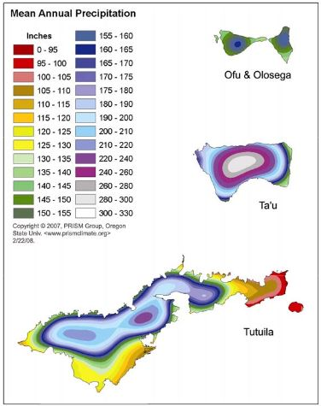

Faga’alu

Figure Mean Annual Precipitation, Tutuila, American Samoa (Craig 2009)

Two watersheds were studied: Faga’alu (1.86 km2) and Nu’uuli (2.14km2)(Figure 2). Like many watersheds on Pacific islands of volcanic origin, both watersheds are characterized by large areas of undisturbed, steeply-sloped, heavily forested hillsides in the upper watershed, some small agricultural plots on the steep hillsides near the village, and relatively little flat area that is urbanized or densely settled in the lower watershed (Tuitele-Lewis, 2004). Faga’alu also includes two unique features not found in “typical” watersheds in American Samoa: 1) an open aggregate quarry and 2) large impervious area associated with a hospital in Faga’alu watershed (Figure 3). Nu’uuli watershed is adjacent Faga’alu, and similar in precipitation, size, relief, and landcover, providing an opportunity to assess sediment loading from a more “typical” watershed, and estimate the influence of the quarry and impervious area in Faga’alu. Initial monitoring efforts focused on Faga’alu, which drains to a sediment-impacted reef (Aeby et al., 2006). Monitoring in Nu’uuli was later established for comparison with Faga’alu. Data analysis for Nu’uuli could not be completed for this analysis, but will be added in future work.

### Faga’alu

In the literature, “Faga’alu” refers to the administratively-defined watershed management unit outlined by the white dotted line in Figure 3, with a total drainage area of 2.5 km2 (Figure 3). This administrative watershed includes the main perennial stream draining an area of 1.86km2, and several small ephemeral streams that drain the lower portions of the watershed (0.63km2) directly to the ocean. The ephemeral streams contribute to total sediment loading to Faga’alu Bay during storms but were not included in this study due to logistical constraints.

This study is focused on the portion of the watershed where small tributaries from the uplands feed a single perennial stream which runs ~3 km from a maximum elevation 653 m.a.s.l. to its outlet at the Pacific Ocean, draining an area of 1.86 km2, hereafter “Faga’alu watershed”. The gauging site at VILLAGE is just above the influence of high tide, and includes 1.78km2 of the watershed drained by Faga’alu Stream. A shallow reef flat (0.5-5m depth) extends about 650m from the stream mouth creating a fringe reef/lagoon environment in Faga’alu Bay.

### Nu’uuli

“Nu’uuli” is an administratively-defined watershed management unit that encompasses several streams draining to the enclosed Pala Lagoon (Pedersen Planning Consultants, 2000). The largest stream in this management unit is Papa Stream (Wong, 1996), which runs ~3km from a maximum elevation of 653 m.a.s.l. to its outlet in the Pala Lagoon and drains an area of 2.14 km2. Though measurements are made only on Papa Stream, for consistency with other reports and maps this site will be referred to simply as “Nu’uuli” hereafter.

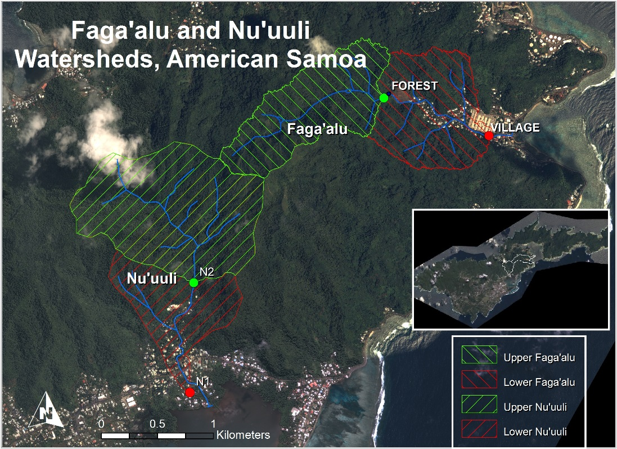

Figure Faga'alu and Nu'uuli watersheds, comprised of upper (forested) and lower (village) subwatersheds, drain opposite sides of Matafao Mtn., the highest point on Tutuila (653m). Inset shows locations of barometric pressure stations (Tafuna, Faga’alu, NSTP6, Tula).

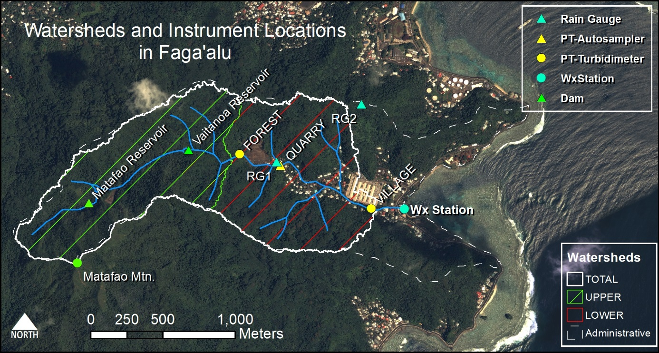

Figure Faga’alu watershed and instrument locations. Grab samples for suspended sediment concentration (SSC) were collected at all three PT locations.

### Land Cover/ Land Use

Land use in both Faga’alu and Nu’uuli watersheds includes agriculture, roads, and urbanization (Table 1). The predominant land cover in the Faga’alu and Nu’uuli watersheds is undisturbed forest on the steep hillsides (85.7% and 93.3%). These forests are prone to natural landslides that can contribute sediment during storm events (Buchanan-Banks, 1979; Calhoun and Fletcher, 1999). Compared to other watersheds on Tutuila, a relatively large portion of Faga’alu watershed is urbanized (“high intensity developed in Table 1, 4.6%), due to large areas of impervious surface associated with the hospital and the numerous residences and businesses. A small portion of the watershed (1.1%) is developed open space, which includes landscaped lawns and parks.

In addition to some small, household gardens there are several small agricultural areas growing banana and taro on the steep hillsides. In both Faga’alu and Nu’uuli, the NOAA Land Cover map (2.5m res.) classified the agricultural plots as “Grassland” due to the high grass cover in the plots (Table 1) (NOAA’s Ocean Service and Coastal Services Center, 2010). These plots are currently receiving technical assistance from the Natural Resource Conservation Service (NRCS) to mitigate erosion problems.

|  |  |  |  |  |  |  |  |  |
| --- | --- | --- | --- | --- | --- | --- | --- | --- |
| Table . Land use categories in Fag'alu and Nu'uuli watersheds. | | | | | | | | |
| **Watershed** | **Cumulative Area km2** | **%** | **% High Intensity Developed** | **% Developed Open Space** | **% Grassland**  **(agriculture)** | **% Forest** | **% Scrub/ Shrub** | **% Bare Land** |
| ***Faga’alu*** | | | | | | | | |
| *FOREST (UPPER)* | 0.90 | 48% | 0% | 0% | 0.1% | 82.4% | 17.1% | 0.4% |
| *QUARRY* | 1.17 | 63% | 0.2% | 0% | 0.2% | 84.7% | 13.3% | 1.6% |
| *VILLAGE (TOTAL)* | 1.78 | 95% | 3.2% | 0.9% | 0.2% | 85.7% | 9.0% | 1.1% |
| *Fag’alu total* | 1.86 | 100% | 4.6% | 1.1% | 0.2% | 84.5% | 8.6% | 1.0% |
| ***Nu’uuli*** | | | | | | | | |
| *Upper* | 1.49 | 70% | 0% | 0% | 0% | 94.8% | 5.2% | 0% |
| *Lower* | 2.14 | 100% | 2.0% | 0.8% | 0.1% | 93.3% | 3.7% | *0.2%* |

In Faga’alu there is an open-pit aggregate quarry (~2ha) that accounts for the majority of the 1.1% bare land area in Faga’alu watershed (

Table 1). The quarry has been in continuous operation since the 1960’s by advancing into the steep hillside to quarry the underlying basalt formation (Latinis 1996). The quarry operators have installed some sediment management practices such as silt fences and settling ponds (Horsley-Witten, 2011) but they are unmaintained and likely inadequate to control the large amount of sediment mobilized by the intense tropical rains (Horsley-Witten, 2012a). Longitudinal sampling of Faga’alu stream in 2011 showed significantly increased turbidity downstream of the quarry and of a new bridge construction site on the village road (Curtis et al., 2011). Construction of the bridge was completed March 2012 and no longer increases turbidity. There are several small footpaths and unpaved driveways, but most unpaved roads are stabilized with compacted gravel and do not appear to be a major contributor of sediment (Horsley-Witten, 2012b).

Three water impoundment structures were built in the upper Faga’alu watershed for drinking water supply and hydropower but only the highest, Matafao Reservoir, was ever connected to the municipal water system but has since fallen out of use (Tonkin & Taylor International Ltd., 1989). In Nu’uuli, no water impoundment structures were observed in the field or found in the literature.

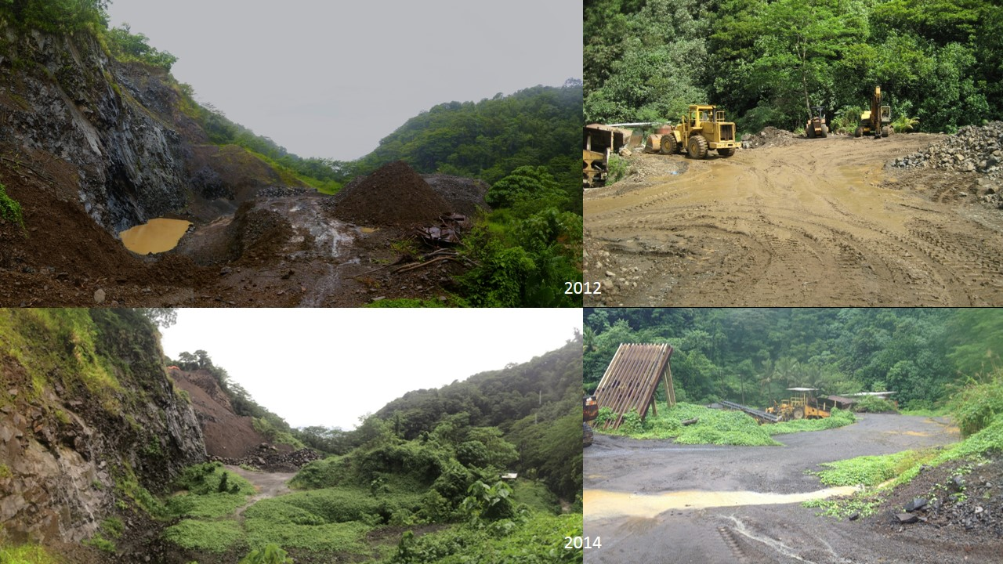

Figure Photos of the open-pit aggregate quarry in Faga'alu in 2012 (Top) and 2014 (Bottom). Photo: Messina

# Methods

While steep, mountainous streams can discharge a high amount of bedload (Milliman and Syvitski, 1992), this research focused on sediment size fractions that can be harmful to corals (Bartley et al., 2014). Field observations suggest that sediment particles larger than fine sand settle before reaching the corals and are not important for this study. Sediment will hereafter refer to particle sizes less than 16*u*m (fine sand). The fine fraction is not a transport capacity-limited load and cannot be predicted from stream-power-related sediment transport models, necessitating the use of empirical models like the sediment rating curve (Asselman, 2000).

## Sediment Rating Curves

A simple method to quantify and compare sediment loading spatially or temporally is with annual or seasonal totals. However, annual or seasonal SSY can be influenced by climatic variability, leading to uncertain assessments of human impact and management effectiveness for the full range of storm sizes and interannual variability in storm number, size and sequence. Another approach is to assess changes in the sediment rating curve, which describes the relationship between instantaneous stream discharge (Q) and suspended sediment concentration (SSC). Sediment rating curves are the most common method used to estimate SSY in streams where sediment concentration data are not available, or to characterize and compare streams in time or space (Araujo et al., 2012; Walling, 1977). The sediment rating curve approach has been applied by many researchers, but is complicated by hysteresis effects, does not assess total sediment loading, and is difficult to compare between watersheds (Asselman, 2000; Zimmermann et al., 2012).

An alternative approach is to compare total SSY during storm events of the same magnitude or with similar characteristics (depth of precipitation, peak discharge rate etc.). In the study watersheds, total SSY over a time interval or storm event was calculated using event mean concentration from a number of discrete grab samples (Harmel et al., 2006), or by summing continuous suspended sediment load measurements (SSC x Q) from turbidity measurements (Duvert et al., 2012):

Equation Event-Wise Suspended Sediment Yield

|  |  |  |
| --- | --- | --- |
|  |  | Equation 1 |
| where *SSYev* is total event sediment load (Mg), *SSC* is suspended sediment concentration (mg/L), and *Q* is discharge (m3/sec). | | |

Event-based SSY from the same size storm can be used to compare SSY from different watersheds (Basher et al., 2011; Duvert et al., 2012; Fahey et al., 2003; Hicks, 1990), assess the contribution of individual subwatersheds to total SSY from a watershed (Zimmermann, Francke, & Elsenbeer, 2012), or determine changes in SSY from the same watershed over time (Bonta, 2000). Methods for parameterizing the event-based sediment rating curves are similar to those for instantaneous sediment rating curves, the most common being ordinary least squares regression on log-transformed data summed by storm event.

## Definition of a Storm Event

Storm events can be defined by precipitation (Hicks, 1990) or discharge (Duvert et al., 2012) parameters. The method used to separate storm events on the hydrograph can significantly influence the analysis of event-based SSY. Complex graphical or rule-based techniques for hydrograph separation may be implemented (Dunne and Leopold, 1978), but for this analysis the simple stage height threshold rule was used (Fahey et al., 2003). A storm event was defined as the time interval where the water depth at FOREST exceeded the long term mean water depth plus one standard deviation (9cm) for more than two hours. This stage height threshold corresponded to a discharge of 53 L/sec. Event precipitation included from thirty minutes before the stage height exceeded the storm-event threshold.

A possible shortfall in the simple threshold rule is the delineation of multi-peaked or “complex” events (Gellis 2013). Complex events have hydrograph peaks that are generated by separate rainfall events, but are closely spaced so the recession limb of the storm hydrograph does not fall below the baseflow threshold before rising again. The number and magnitude of hydrograph peaks in a storm event can cause different suspended sediment responses, but defining multiple peaks as separate storms can still be considered qualitative or accomplished by arbitrary rule-based schemes. Several events were identified as complex events, and were split into individual storm events using a qualitative analysis of precipitation data to identify which hydrograph peaks were generated by separate storms.

## Statistical analysis of predictors of SSY

Sediment yield during a storm event (SSYev) may depend on characteristics of precipitation (total storm depth, intensity) or of the discharge (total discharge volume, peak discharge). Four predictors used for this analysis were total event precipitation (Psum), EI30 rainfall erosivity (EI30) (Hicks, 1990), total event discharge (Qsum), and maximum event discharge (Qmax) (Duvert et al., 2012). Predictor variables may be linearly or nonlinearly correlated with SSY, so both Pearson’s and Spearman’s correlation coefficients were calculated from non-transformed data to select the best predictor of event SSY from the UPPER, LOWER, and TOTAL watershed. The Pearson's correlation coefficient is a measure of the linear [correlation](http://en.wikipedia.org/wiki/Correlation) between predictor variables and SSY, giving a value between +1 and −1, where 1 is total positive correlation, 0 is no correlation, and −1 is total negative correlation. Pearson’s r may be sensitive to outliers and to non-normal distributions of data with small sample sizes, so Spearman’s rank correlation coefficient was also calculated. Spearman’s rank correlation coefficient is a nonparametric measure of correlation between predictor variables and SSY, by assessing how well the relationship can be described using a [monotonic](http://en.wikipedia.org/wiki/Monotonic) function, even if it is nonlinear, if there are outliers, or if the dataset is small and highly non-normal.

Four predictors of event SSY were tested to determine which had the highest correlation, and would be selected for the final model of event-based SSY. The four predictors tested were Total Event Precipitation (Psum), Event Erosivity (EI), Total Event Discharge (Qsum), and Maximum Event Discharge (Qmax). Qmax for the UPPER watershed was measured at FOREST. Qmax for the TOTAL watershed was measured at VILLAGE. Qmax measured at VILLAGE was also used for the LOWER watershed.

The EI is one of the factors in the USLE (spell out) and is the product of the storm rainfall energy (E) and the 30-minute Max Intensity (I30) (Galetovic et al., 1998):

Equation . Erosivity Index

|  |  |
| --- | --- |
|  | Equation 5 |
| where ir is average storm rainfall intensity (in/hr), and I30 is maximum 30-min. rainfall intensity. | |

Pearson’s and Spearman’s correlation coefficients were calculated for non-transformed predictor data and event SSY (Duvert et al., 2012).

## Fitting regression models

The relationship between event SSY and Q metrics (Qm), like total event Q or event max Q, are often best fit by a watershed-specific power law function of the form:

Equation SSY-Qmax Power function

|  |  |  |
| --- | --- | --- |
|  |  | Equation 2 |
| where the regression coefficients α and β are obtained by ordinary least squares regression on the logarithms of *SSYev* and *Qm* (Basher et al., 2011; Duvert et al., 2012; Hicks, 1990). | | |

While the relationship of SSY to various predictor variables has been best described as a power law in other watersheds, the data collected in Faga’alu could be fit by a linear function in some cases. For this analysis, two methods were used to fit a regression model for each predictor variable and SSY: 1) ordinary least squares regression on non-transformed data (LINEAR model), and 2) ordinary least squares regression on log-transformed data (POWER law model). A coefficient of determination (r***2***) was calculated to determine which model best fit the data.

## Determining human impacts on suspended sediment yield (SSY)

### Comparing SSC samples during base- and stormflows using boxplots and EMC (MEC)

5 methods to calculate mean sediment concentration from field data

the value of any ap- proach is dependent on an adequate spread of samples across the hydrograph. The

MEC: ‘mean’ concentrations are based on direct measurements of concentration rather than…

EMC: using the concentration data to estimate a load, and then deriving a flow weighted (or indirect) concentration by dividing the load by flow.EMC is a flow-weighted average of concentration and is reported in units of milligrams per liter (Charbeneau and Barrett, 1998). It is defined as total constituent mass, M, discharged during an event divided by total volume (V) of discharge during an event (Huber, 1993) (Bartley et al., 2012)

### Comparing SSY-Qmax models

It was hypothesized that the relative increase in SSY from human disturbance is highest for small storms when easily eroded sediment from disturbed surfaces in the lower watershed is the dominant source, but for large storms the dominant sediment source becomes mass movements and bank erosion from the much larger undisturbed uplands. To test this hypothesis, area-normalized SSY from the undisturbed, UPPER and human-disturbed, TOTAL watersheds were compared over a range of storm sizes.

### Sediment budget

Another approach to quantify the impact of human disturbance on SSY is the use of a sediment budget (Warrick and Mertes, 2009). The sediment budget quantifies the contribution of key sediment sources or subwatersheds to the overall sediment yield from the total watershed (Slaymaker, 2003). Specific sediment yield from key land uses or areas can be used to calculate the total contribution to total sediment loading. The objective of this research was to quantify the total human impact on sediment loading to the bay as it relates to increased coral sedimentation. Analysis of specific human disturbances like urban, quarrying, or agriculture would be useful for focusing further management, but are outside the scope of this analysis.

The total Faga’alu watershed (TOTAL), draining to VILLAGE, was separated into two nested subwatersheds for analysis: the upstream, undisturbed forest portion of the watershed (UPPER), and the downstream, human-disturbed portion of the watershed (LOWER) (Figure 3). SSY from the UPPER watershed (SSYUPPER) is measured at FOREST, and SSY from the total watershed (SSYTOTAL) is measured at VILLAGE. For each storm event, the SSY from the UPPER watershed can be subtracted from the SSY from the TOTAL watershed to find the contribution of the human-disturbed LOWER watershed (SSYLOWER = SSYTOTAL -SSYUPPER). The percent contribution from subwatersheds to SSYTOTAL was calculated for UPPER (SSYUPPER/SSYTOTAL) and LOWER (SSYLOWER/SSYTOTAL), and averaged to determine the contribution (%) from each subwatershed to total sediment loading.

The sediment loading at the downstream VILLAGE site is the sum of contributions from the upper, forested watershed, forested parts of the lower watershed, and human-disturbed portions of the lower watershed:

SSYVILLAGE = SSYUPPER + SSYLOWER-FOREST + SSYLOWER-HUMAN

SSYLOWER-FOREST is estimated as the specific sediment yield of the upper watershed times the area of the lower watershed in forest cover:

SSYLOWER-FOREST = SSYUPPER *(Area LOWER-FOREST /AreaUPPER)

The SSYLOWER-HUMAN is then calculated by difference.

The disturbance ratio is the ratio of SSYVILLAGE under current conditions to SSYVILLAGE under pre-disturbance conditions:

DR = SSYVILLAGE/(SSYUPPER + SSYUPPER*(AreaTOTAL/AreaUPPER))

The separate contributions of the quarry and village can be determined as:

What about the sediment sampling at Quarry? Didn’t you calculate the contribution there?

## Uncertainty

Throughout this manuscript, ‘‘error’’ and ‘‘uncertainty’’ are used synonymously and are defined as random variation affected by the appropriate use of accepted procedures (Haan, 2002).

Uncertainty associated with the sediment yield estimates arises from measurement and model errors. Measurement errors include errors in the rain gauge measurements due to spatial or orographic heterogeneity, errors in stage height from barometric pressure correction, errors in discharge measurements associated with the area-velocity method, and sensor drift of optical turbidity instruments, etc. Model errors include the variance in the stage-discharge relationship, variance in turbidity-SSC relationship, and the fitting of rating curves to these relationships. Errors are propagated through the estimates of event SSY so some measure of uncertainty in the final estimate is warranted, but outside the scope of this paper.

Various methods….(Navratil et al., 2011; Zimmermann et al., 2012) used Monte Carlo approach while (Warrick and Mertes, 2009) estimated sediment yield using the uncertainty extremes (i.e. lowest discharge x lowest SSC vs. highest discharge x highest SSC). Or RMSE method

Navratil identified areas of uncertainty in ….

Here we focus on errors in Stage-Q and T-SSC….

Substantial uncertainty can be contributed by each procedural category (discharge measurement, sample collection, sample preservation/storage, laboratory analysis, and data processing and management). For storm loads, the uncertainty was typically least for discharge (?7–23%), greater for sediment (?16–27%) and dissolved N and P (?14–31%) loads, and greater yet for total N and P (?18–36%). When these uncertainty estimates for individual values were aggregated within study periods (i.e. total discharge, average concentration, and total load), uncertainties followed the same pattern (Q < TSS < dissolved N and P < total N and P) (Harmel et al., 2009) uncertainty due to missing or incorrect values later became apparent, and the data processing and management procedural category was added. This

The uncertainty in continuous stage measurement is mainly determined by stage sensor accuracy, presence/ absence of a stilling well, and channel bed conditions (Pelletier, 1988; Sauer and Meyer, 1992). Uncertainty introduced by translating continuous stage measurements into discharge is determined to a large extent by the presence/absence of a hydraulic control structure, the stability of the channel, and the range of measured flows used to develop the relationship (Dickinson, 1967; Pelletier, 1988; Sauer and Meyer, 1992; Herschy, 1995; Schmidt, 2002).(Harmel et al., 2009)

the root mean square error (RMSE) method to propagate uncertainty from each component to estimate the cumulative uncertainty in individual discharge, concentration, and load values. The RMSE method estimates the ‘‘most probable value’’ of the cumulative or combined error by propagating the error from each procedure (Topping,1972). The resulting cumulative probable error, hereby called uncertainty, is defined as the square root of the sum of the squares of the maximum values of the separate errors.

|  |  |  |
| --- | --- | --- |
|  |  |  |
| where EP is the cumulative probable error or uncertainty for individual measured values (±%), EQ = uncertainty in discharge measurement (±%), ESSC = uncertainty in suspended sediment concentration from turbidity measurements (± %), | | |

## Field data collection

To calculate event SSY from Faga’alu and Nu’uuli watersheds, data on precipitation, discharge, suspended sediment concentration, and turbidity were collected over three field campaigns and several periods of unattended monitoring from January, 2012, to March, 2014. Only data collected in Faga’alu will be included in the following analysis.

### Precipitation (P)

Precipitation (P) was recorded with Rainwise RAINEW tipping-bucket rain gages at 1 minute intervals at three locations in Faga’alu watershed (Figure 3) and two locations in Nu’uuli watershed (N1 and N2; Figure 2). Data at RG2 was only recorded January-March, 2012, to determine a relationship between elevation and precipitation. Precipitation at 15 minute intervals was also measured at the Vantage Pro Weather Station (Wx) and used to fill any data gaps in the precipitation recorded at RG1. The event total precipitation (Psum) and EI30 were calculated from RG1. Annual total precipitation was calculated using RG1, with data gaps filled by data from Wx.

### Discharge (Q)

Water stage was measured at 15-minute intervals with non-vented pressure transducers (PT) (Solinst Levelogger or Onset HOBO Water Level Logger) installed at three locations in Faga’alu watersheds (Figure 3). Stream gauging sites were chosen to take advantage of existing control structures (FOREST) or stabilized streambed and banks (VILLAGE, N1, and N2)(Figure 2, Figure 3). Barometric pressure data was collected at a Davis Vantage Pro weather station (Wx) installed in Faga’alu watershed (Figure 3). Data gaps were filled by barometric data from National Data Buoy Center station (NSTP6) in Pago Pago Harbor, Tafuna International Airport, and NOAA Climate Observatory at Tula (Figure 2, inset). Priority was given to the closest station with valid barometric pressure data. Stage height is calculated as:

Equation Correcting PT with barometric pressure

|  |  |  |
| --- | --- | --- |
|  |  | Equation 3 |
| where *Stage* is stage height (cm), *PT* is recorded pressure from the PT (hPa ), *Baro* is barometric pressure (hPa), *g* is acceleration due to gravity (9.81ms-2), *ρ* is density of water (1kg L-1), and *100* is for units conversion (cm m-1). | | |

Stage-discharge relationships were developed by fitting linear and log-linear functions to measurements of cross section area (A) and velocity (V) of flow (Figure 5). For high stages at FOREST, flow measurements were not available so velocity and discharge were estimated using Win-Flume. Discharge was measured in the field by the area-velocity method using a Marsh-McBirney flowmeter to measure flow velocity and channel surveys to measure stream cross-section geometry (Harrelson et al., 1994; Turnipseed and Sauer, 2010). Flow speed measured at the center of 1 foot sections is multiplied by the cross-sectional area of the section, and summed over the whole cross-section to calculate volumetric discharge. Area-Velocity discharge measurements (A-V) were made under baseflow and stormflow conditions at FOREST and VILLAGE in Faga’alu, and linear and log-linear rating curves were fitted.



At FOREST, an uncontrolled ogee spillway at an existing stream impoundment was used to model discharge.

Winflume was developed by the U.S. Bureau of Reclamation to design and calibrate long-throated flume and broad-crested weir flow measurement structures (USBR 2012). The software can also be used to simulate an existing structure by inputting the dimensions of the structure and simulating a rating curve. WinFlume was used at the FOREST site because A-V measurements were unreliable at low discharges, and A-V measurements could not be made at high discharges due to safety issues with wading in the spillway of the control structure. At stages over 45cm the water level exceeds the height of the narrow channel and flows over the crest of the control structure, causing a significant change in the stage-discharge relationship that could not be predicted from A-V measurement. WinFlume was calibrated with A-V measurements and used to predict discharge at all stages.

### Suspended Sediment Concentration (SSC)

A main objective of this research was to identify and quantify key sediment sources in Faga’alu to focus future management efforts. Sediment rating curves have been used to derive continuous SSC if Q data is available (Walling, 1977), but this is only possible if SSC shows a bijective relationship with Q. Data from the study site showed only weak correlation between Q and SSC, with significant hysteresis during storm- and baseflows, so alternative methods were needed. The sediment rating curve can be divided by rising stage and falling stage samples, continuous SSC can be modeled using Regression Tree approaches (Zimmermann et al., 2012), or continuously monitored turbidity data can be used to model SSC (Gippel, 1995; Minella et al., 2008).

Curtis et al. (2011) found statistically significant increases in turbidity below the quarry (QUARRY) and bridge construction but measured turbidity was not calibrated to SSC samples. Bridge construction has been completed and is no longer a source of increased turbidity. Due to logistical constraints, continuous event-based SSY could only be measured upstream and downstream of the village. To identify significant increases in sediment loading within the village watershed, stream water SSC samples were also collected at QUARRY, and compared to FOREST and VILLAGE for any statistically significant patterns.

From January 6, 2012, to February 26, 2014, 610 samples were collected at 14 sites in Nu’uuli and Faga’alu watersheds and analyzed for SSC. Stream water samples were collected by grab sampling with 500mL HDPE widemouth bottles at FOREST, QUARRY, VILLAGE, N1 and N2, and by ISCO 3700 automatic pump samplers at QUARRY, N1, and N2. Water samples were vacuum filtered on 47mm, 0.7um Millipore AP40 glass fiber filters, oven dried at 100˚C for one hour, cooled and weighed to determine SSC (mg/L) (Gray et al., 2000). Three main sampling locations in Faga’alu are the focus in this analysis: 1) Upstream (FOREST)(n=55), 2) immediately downstream of the Quarry (QUARRY)(n=247), and 3) Downstream (VILLAGE)(n=155).

Stream water samples collected over a range of Q and SSC were used to calibrate a linear relationship between turbidity and SSC, to convert continuous turbidity to continuous SSC. The turbidity-SSC relationship is unique to each region, or even each stream, and can be influenced by water color, dissolved solids and organic matter, temperature, and the shape, size and composition of sediment particles. However, turbidity has proved to be a robust surrogate measure of SSC in streams (Gippel 1995) and is widely used for remote monitoring applications (Lewis 1996).

Turbidity was measured at 5 minute intervals at FOREST, VILLAGE, N1, and N2. Turbidity was measured at VILLAGE using a YSI 600OMS sonde with 6136 Turbidity Probe from February 2012 until it was damaged in May 2012. As a replacement, a CampbellSci OBS500 was then deployed at VILLAGE in March 2013 to March 2014, with no data from August 2013 –January 2014 due to instrument malfunction. A new CampbellSci OBS500 was installed at VILLAGE and recorded turbidity from January to March, 2014. Turbidity was measured at FOREST using a Greenspan TS3000 turbidimeter from January 2012 to July 2012 when it was vandalized and destroyed. The YSI turbidimeter was repaired and redeployed at FOREST June 2013 to October 2013, and January 2014 to March 2014. At N1 and N2, a CampbellSci OBS500 turbidimeter was installed February to March 2014. Turbidity of grab samples was also measured in the laboratory by a LaMotte 20/20 turbidimeter (LAB) to compare to turbidity measured in the field (Figure 8a). Turbidity data was resampled to 15 minute intervals to match the discharge data interval for calculating suspended sediment load (Equation 1).

SSC samples and corresponding 5 minute interval turbidity data were used to calibrate a turbidity-SSC relationship (T-SSC) for in situ turbidimeters. The VILLAGE-YSI rating was used to convert turbidity from all instruments to SSC, due to its good fit over the full range of SSC samples.

(Navratil et al., 2011) says you have to use T-SSC AND hysteretic relationships for inter-event comparison. T should be measured over 1min. and averaged to lower uncertainty (30% to 18%).

# **Results and Discussion**

## Field Data Collection

### Precipitation (P)

Despite the orographic increase in rainfall shown in long term records (Craig, 2009), comparing rain gauge data from Faga’alu didn’t show any orographic relationship between RG1 and Wx, or RG1 and RG2, so precipitation was assumed to be homogenous over the watershed for all analyses. Rainfall data measured at higher elevations would be useful to determine a more robust orographic rainfall relationship. Annual precipitation measured at RG1 was 3,350mm and 3,443mm in 2012 and 2013 respectively. These annual rainfall amounts are approximately 73% of long-term Parameter-elevation Relationships on Independent Slopes Model (PRISM) rainfall data (=4500-4800mm)(; Craig, 2009).

### Discharge (Q)

The log-linear A-V rating curve had the lowest RMSE and highest r2 and was selected at the VILLAGE site. A-V measurements could not be made at high discharges at FOREST due to safety concerns so a rating curve was developed using WinFlume (US Bureau of Reclamation, 2012). Discharge was characterized by periods of low but perennial baseflow (FOREST: 7-53 L/sec), punctuated by short, flashy hydrograph peaks (FOREST: max 2,606 L/sec).

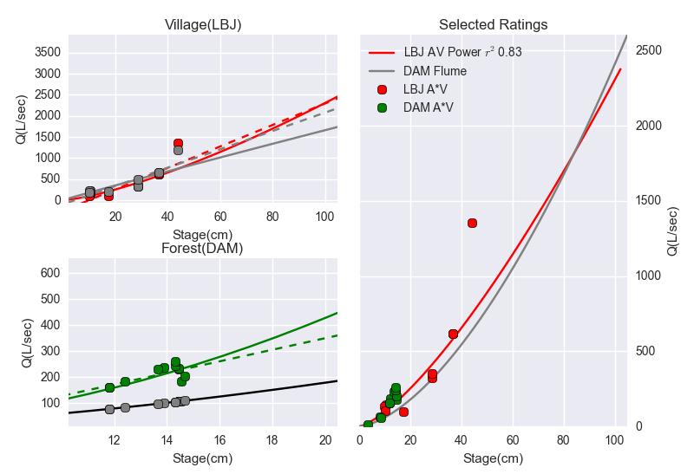

Figure . Stage-Discharge rating curves for a) VILLAGE and b) FOREST gauging stations in Faga'alu, and c) the final selected rating curves for both sites. Red (a, c) and green (b,c) dots indicate in-situ measurements. Solid red (a,c) and green lines (b) indicate log-linear rating curves fit to in situ measurements. Dotted red (a,c) and green lines (b) indicate linear rating curves fit to in situ measurements. Dotted grey lines indicate linear rating curve fit to data modeled by Manning’s equation Grey dots (a,b) indicatemodeled values from Manning’s equation (Village), and WinFlume (Forest). The selected rating curve is plotted over the entire range of stage measured 2012-2014 (c).

### Suspended Sediment Concentration (SSC)

Mean SSC values for all samples (baseflow and stormflow ) were lowest at the FOREST site (32mg/L), highest at the QUARRY (213mg/L), and intermediate at the donwstream (VILLAGE) site (144mg/L) (Table 2) . Maximum SSC values were 500mg/L, 12,600 mg/L, and 3,500 mg/L at the upstream (FOREST), quarry (QUARRY), and downstream (VILLAGE) sites, respectively. The maximum SSC values for the quarry (12,600 mg/L ) and downstream (3,500 mg/L) sites were sampled during the same event March 5, 2012, during fairly low discharge (Q_VILLAGE=105 L/sec). The maximum SSC value for the upstream site (500 mg/L) was sampled on April 23,2013 at high discharge (Q_FOREST=1,398 L/sec) (Table 2). Anecdotal and field observations reported higher than normal SSC upstream of the quarry during the 2013 field season (G. Poysky, pers. comm.).

|  |  |  |  |  |  |  |
| --- | --- | --- | --- | --- | --- | --- |
| Table . Mean and Maximum SSC (mg/L) at three sampling locations in Faga'alu. | | | | | | |
| *\*SSC (mg/L)* | **Upstream (FOREST)** | | **Quarry (QUARRY)** | | **Downstream (VILLAGE)** | |
|  | *Mean* | *Max* | *Mean* | *Max* | *Mean* | *Max* |
| **Stormflow** | 44  (n=33) | 500 | 173  (n=127) | 2,986 | 130  (n=87) | 1,060 |
| **All** | 32  (n=55) | 500 | 213  (n=247) | 12,600 | 144  (n=155) | 3,500 |

At FOREST, 33 samples (60%) were taken during stormflow conditions (Q_DAM>54 L/sec), with mean SSC of 44 mg/L. At QUARRY, 127 samples (48% of all samples) were taken during stormflow conditions (Q_DAM>54 L/sec); and mean SSC for QUARRY stormflow samples was 173 mg/L. At VILLAGE, 87 samples (56%) were taken during stormflow conditions (Q_VILLAGE>150 L/sec); and mean SSC for VILLAGE stormflow samples was 130 mg/L (Table 2). This pattern of SSC values suggests there is a large input of sediment downstream of FOREST at the quarry, and then SSC is diluted by addition of stormflow with lower SSC between QUARRY and VILLAGE.

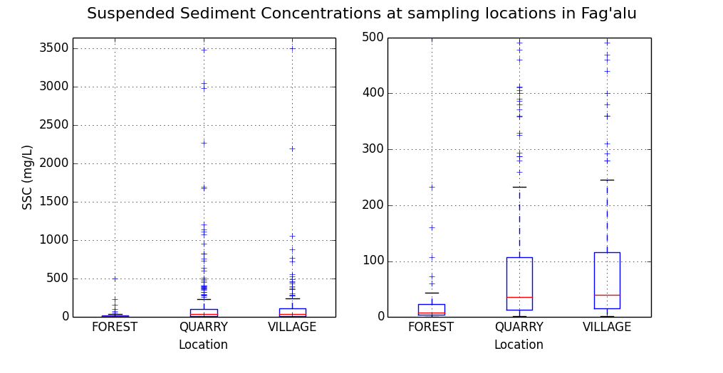

**A**

B

Figure . Boxplots of SSC at the three main sampling locations. A) Full range of SSC measured (0-3,500 mg/L) B) shows a zoomed in view (0-500 mg/L).

Given the close proximity of the quarry to the stream, SSC downstream of the quarry can be highly influenced by mining activity. Prior to 2013, a common practice for removing fine sediment from crushed aggregate was to rinse it with water pumped from the stream. The fine sediment was discharged directly into the stream, causing high SSC during low discharges. While sheetwash erosion of the quarry during storms causes higher total sediment loading, the instantaneous SSC are lower due to dilution by stormflow. The practice of manually rinsing fine sediment from aggregate was discontinued in 2013, corresponding with a lack of high SSC grab samples during low discharges (Figure 7).

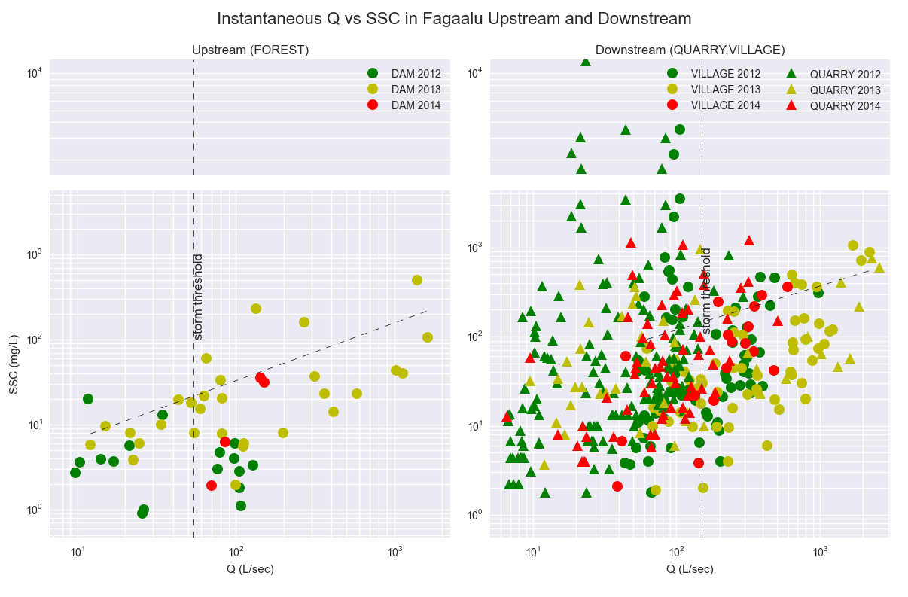

**A**

B

Figure . A: Discharge vs. Suspended Sediment Concentration in upstream grab samples (FOREST) and B: Discharge vs. Suspended Sediment Concentration in downstream grab samples (QUARRY and VILLAGE). Suspended sediment concentration in grab samples was overall much lower upstream of the human-disturbed LOWER watershed. High values of SSC (2,000-12,000mg/L) were sampled at low discharges in 2012, prior to sediment mitigation practices at the quarry.

### Turbidity

The turbidity-SSC relationship varied among locations and sensors (??, Figure xx). The RMSE in the relationships were xx mg/L at the FOREST site and xx mg/L at the forest site. Due to differences in the turbidity-SSC relationship by instrument, instrument-specific curves were used…?

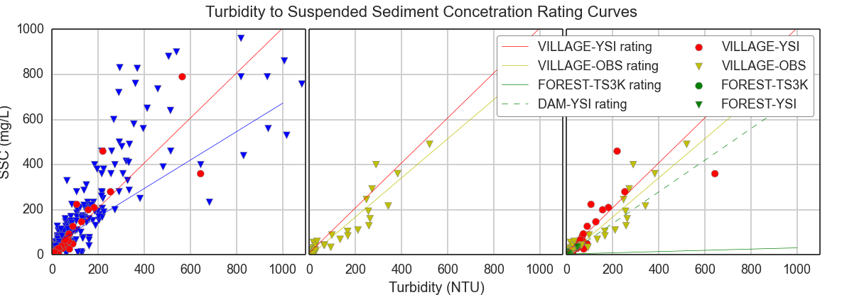

Figure Turbidity-SSC rating curves for turbidimeters in Faga'alu Stream. The VILLAGE-YSI rating (red line) showed good fit over the full range of SSC samples, especially at higher NTU and SSC values, so it was used to convert turbidity from all instruments to SSC.

### Storm Events

Overall, eighty-nine storm events were identified from discharge data from January, 2012, to March 2014 using the stage threshold method, and manual separation of complex storm events (Figure 9). Valid discharge data was recorded during eighty-eight events at FOREST (upstream site), and seventy-two events at VILLAGE (downstream site). Valid turbidity data was recorded during fifty-five events at FOREST, and thirty events at VILLAGE. Twenty-five events had valid precipitation, discharge and turbidity data for both the FOREST and VILLAGE to calculate and compare the sediment loading from the UPPER and LOWER watersheds.

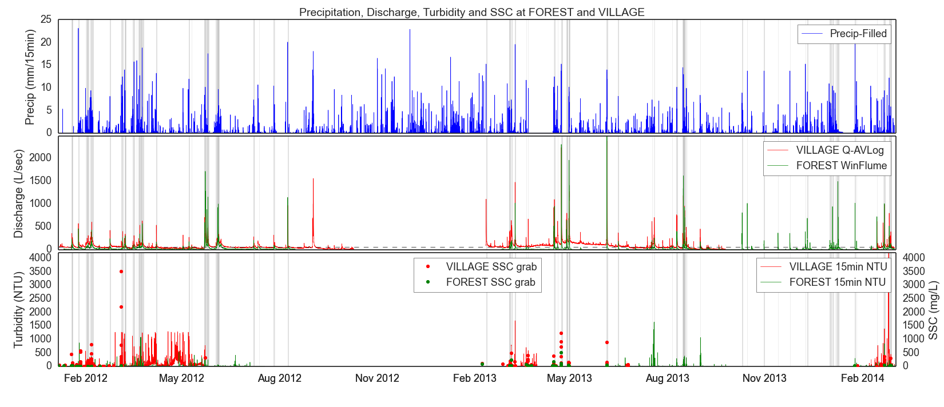

Figure Time series of Precipitation, Discharge, and Turbidity recorded at the upstream (DAM) and downstream sites (VILLAGE) in Faga'alu over all three years. Dots in lower graph represent SSC grab samples (plotted on secondary y-axis). Storm Intervals are shaded in gray.

## Rainfall-Runoff relationships

Since discharge is a primary control on sediment load calculations, any change in the rainfall-runoff relationship could signify some change in the watershed functioning, or complicate the use of event precipitation variables as predictors of SSY. For instance, increased impervious surface to limit surface erosion could increase Q relative to P, causing more channel erosion and increased SSY for the same storm size. This effect would be difficult to determine from the sediment rating curves alone, and would possibly appear as just increased scatter around the Precip-SSY regression line.

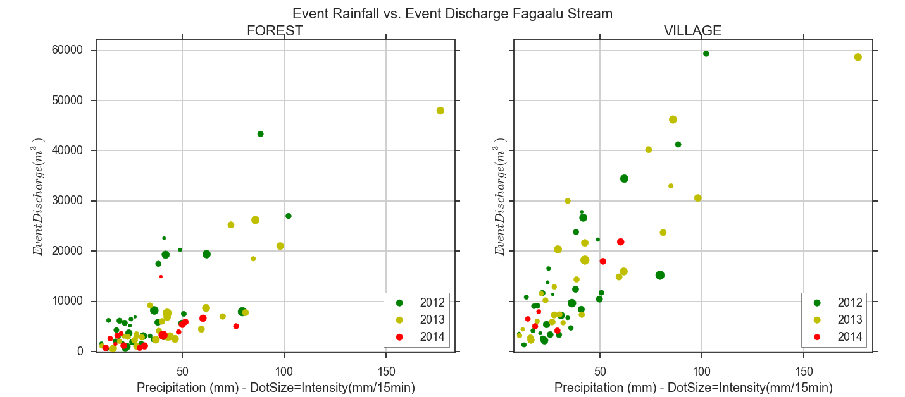

Figure . Rainfall-Runoff relationship for the Upstream (FOREST) and Downstream (VILLAGE) gauging sites. Storms in 2013 (yellow dots) appear mostly in the lower part of the data point cloud, indicating a possible change in the rainfall/runoff relationship. It is difficult to tell since there are no large storm events during the 2014 data. Dot size is proportional to…

The rainfall-runoff relationship at both upstream and downstream locations is fairly linear, and mostly constant from year to year at the downstream site (VILLAGE)(Figure 10). The rainfall-runoff relationship appears to have changed slightly at the upstream site (FOREST) for storm events during the third field campaign in 2014 (Figure 10). This decrease in runoff could have been a consequence of unusually dry antecedent moisture conditions, increased ET, increased interception due to vegetation growth, or upstream impoundment in the defunct dam structures.

In addition to the structure used as a discharge gauging site at FOREST, Faga’alu stream was dammed at 3 locations above the village: 1) Matafao Dam (ele. 244 m) near the base of Mt. Matafao, draining 0.20 km2, 2) Vaitanoa Dam at Virgin Falls (ele. 140 m), draining an additional 0.44 km2, and 3) a small unnamed dam below Vaitanoa Dam at ele. 100m. Matafao Dam was constructed in 1917 for water supply to the Pago Pago Navy base, impounding a reservoir with initial capacity of 1.7 million gallons (6,400 m3) and piping the flow out of the watershed to a hydropower and water filtration plant in Fagatogo. In the early 1940’s the Navy replaced the original cement tube pipeline and hydropower house with cast iron pipe but it is unknown when the scheme fell out of use (Tonkin & Taylor International Ltd., 1989; URS Company, 1978). Remote sensing and a site visit on 6/21/13 confirmed the reservoir is still filling to the spillway crest with water and routing some flow to the Fagatogo site, though the amount is much less than the 10 in. diameter pipes conveyance capacity and the flow rate variability is unknown. A previous site visit on 2/21/13 by American Samoa Power Authority (ASPA) found the reservoir empty of water but filled with an estimated 3-5 meters of fine sediment (Kearns, 2013). Interviews with local maintenance staff and historical photos confirmed the Matafao Reservoir was actively maintained and cleaned of sediment until the early 1970’s. The Vaitanoa (aka Virgin Falls) Dam, was built in 1964 to provide drinking water but the pipe was not completed as of 10/19/89, and a stockpile of some 40 8 in. diameter by 8 ft. length asbestos-cement pipes was found on the streambanks. The Vaitanoa Reservoir had a design volume of 4.5 million gallons (17,000m3), but is assumed to be full of sediment since the drainage valves were never opened and the reservoir was overtopping the spillway as of 10/18/89 (Tonkin & Taylor International Ltd., 1989). A low masonry weir was also constructed downstream of the Vaitanoa Dam, but not connected to any piping. Informant interviews and field visits have documented changing reservoir levels at Matafao Reservoir but reservoir levels at Vaitanoa Reservoir are unknown. Access to these sites is extremely difficult and dangerous so regular visits or instrumentation was not possible.

## Comparing SSY from disturbed and undisturbed subwatersheds

Two approaches were used to determine how much SSY from Faga’alu is contributed by the undisturbed and human-disturbed areas: a sediment budget and a comparison of event-based sediment rating curves (see section 3.5).

### Sediment Budget

A sediment budget approach was first used to determine how much total sediment loading to the Bay is contributed by the upper, undisturbed subwatershed (UPPER), and the lower, human-disturbed subwatershed (LOWER) for storm events with data measured at both locations (FOREST and VILLAGE)(Figure 3). SSY from the LOWER watershed (SSYLower) was calculated by subtracting SSY measured at FOREST from SSY measured at VILLAGE (SSYLower = SSYVILLAGE – SSYFOREST).

SSY from the UPPER watershed (SSYUPPER) accounted for an average of 17% of Total Sediment Loading to the Bay, while sediment yield from the Lower watershed (SSYLower) accounted for an average of 83% of Total Sediment Loading (SSYTotal) (Table 3). The UPPER watershed is 0.90km2 and the LOWER watershed is 0.88km2 so we can assume that the same fraction of total sediment loading, ~17%, is from undisturbed forest in the LOWER watershed. Therefore, 17% of total sediment loading is from undisturbed areas in the UPPER watershed, ~17% of total sediment loading is from the undisturbed areas in the LOWER watershed, and the remaining ~66% of total sediment loading must then be contributed by the quarry and other disturbed areas in the LOWER watershed. A rough estimate then is the disturbed areas in the LOWER watershed account for a ~200% increase in sediment loading above natural conditions to Faga’alu Bay. This is a considerably rough and uncertain estimate, however, since it assumes SSY from natural areas in the LOWER watershed is similar to SSY from natural areas in the UPPER watershed, doesn’t account for the slight difference in watershed size and assumes there is as much undisturbed area in the LOWER watershed as the UPPER watershed.

Table . Suspended Sediment Load by storm event and percent contribution from Upper, Lower, and Total Watersheds.

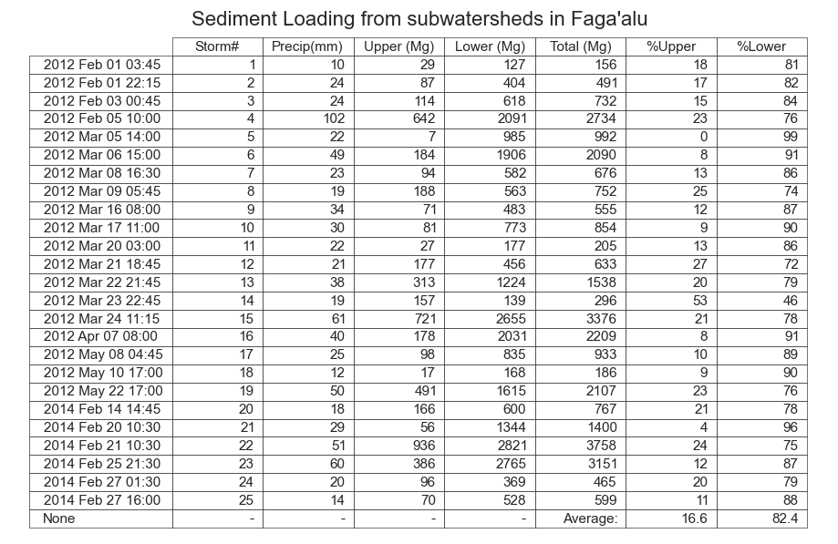

The disturbance ratio is the ratio of SSY.VILLAGE under current conditions to SSY.VILLAGE under pre-disturbance conditions:

DR = SSY.VILLAGE/(SSYupper + SSYupper*(Area.total.wshed/Area.upper))

The separate contributions of the quarry and village can be determined as:

## Comparing predictors of SSY

Similar to Duvert et al. (2012), Pearson’s and Spearman’s correlation coefficients were highest for Qmax for all three watersheds in Faga’alu. Some predictors were highly correlated for a single watershed but not the others, like Qsum for the UPPER watershed. EI was the least correlated with SSY.

Table . Pearson’s and Spearman’s correlation coefficients for non-log-transformed predictive variables compared to SSY (p<0.001). Blank cells were not significant

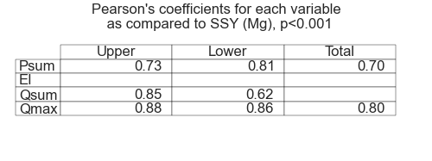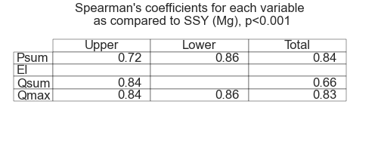

No statistically significant correlations (p<0.001) were found between SSY and EI using Pearson’s or Spearman’s coefficients. Overall, statistically significant Pearson’s and Spearman’s correlation coefficients were fairly similar, indicating the relationship of SSY with the predictor variables is adequately described by a linear function and that outliers and non-normality in the data did not affect the test. The exception was significantly higher Spearman’s correlation coefficient for Psum for the TOTAL watershed Spearman’s=0.84 vs. Pearson’s=0.70). Pearson correlation coefficients were highest overall for Psum and Qmax, indicating these were significantly correlated with event SSY. Qsum showed high correlation with SSY for the UPPER watershed but not the LOWER or TOTAL watershed.

The Pearson correlation coefficients for the UPPER watershed are slightly higher for discharge-related predictors (especially Qsum) and lower for precipitation-type predictors (Psum and EI30) than for the LOWER watershed. This suggests that sediment production processes are more dominated by discharge in the UPPER watershed and precipitation in the LOWER watershed. SSY from the LOWER watershed is hypothesized to be mostly generated by surface erosion at the quarry, dirt roads, and agricultural plots, whereas SSY from the UPPER watershed is hypothesized to be mainly from channel processes and mass wasting. Mass wasting can contribute large pulses of sediment during large precipitation events, which can be deposited in lobes on the streambanks and entrained at high discharges during later events. Qmax may be a promising predictor that integrates these processes.

## Fitting sediment curves

Qmax was the most correlated with event SSY for all three watersheds, and was selected as the best predictor variable (Table 4). To investigate for any patterns not reflected in the Pearson’s and Spearman’s correlation coefficients, regression lines were fit to all four predictor variables using ordinary least squares regression on non-transformed (LINEAR) and log-transformed data (POWER law)(Figure 11).

Interpret Figure 11 for the reader. What do you want them to see in Figure 11? What is important?

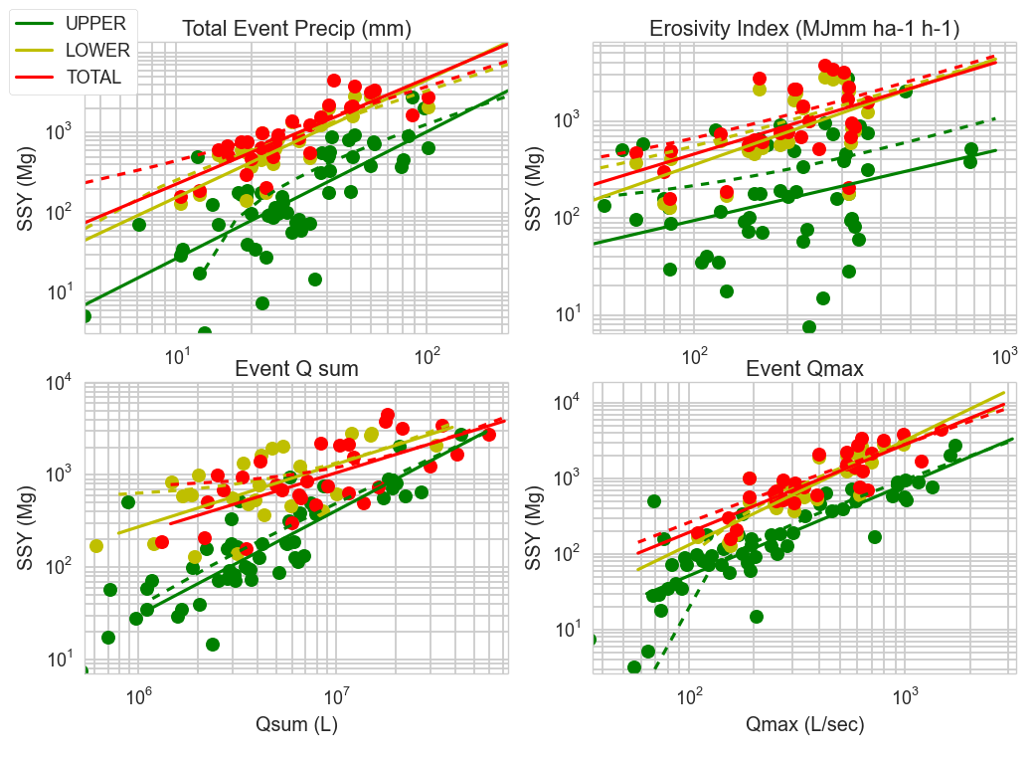

Figure . Linear (dotted lines) and Power Law (solid lines) event-based SSY rating curves for the four tested predictors: total event precipitation, event Erosivity Index, total event discharge, and max event discharge.

Coefficients of determination (R2) were calculated for LINEAR and POWER law regressions fit to the SSY-Qmax relationship for UPPER and TOTAL watersheds. The LOWER subwatershed was excluded for this analysis since a suitable method to normalize Qmax for the subwatershed could not be found in the literature. The LINEAR function achieved a better fit (r2 =0.77) than the POWER law function (r2=0.71) for the UPPER watershed, but not for the TOTAL watershed (r2: linear = 0.64, power=0.72). A main objective of this study was to develop a model of SSY to Faga’alu Bay so the best fit model for the TOTAL watershed was selected. All examples found in the literature also used the Power law function, so for better comparison with other studies, the POWER law model fit to event SSY-Qmax was selected as the best model (Figure 12, Table 5). Future analysis could also compare the log-transformed linear with bias correction and nonlinear fitting methods in Duvert et al. (2012) but they were not performed for this analysis.

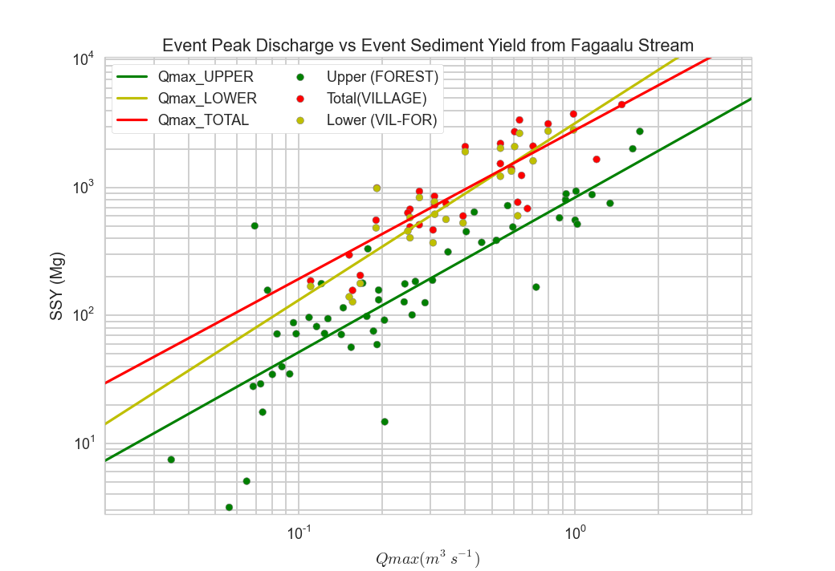

Figure . Event-based SSY rating curves for the UPPER, LOWER, and TOTAL watershed.

Table . Model coefficients α and β for SSYevent (tons/event) and Qmax (L/sec). r2, Pearson’s correlation and Spearman’s rank coefficients are for log-transformed Qmax and SSY.

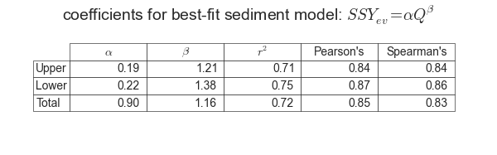

## Comparing human impact on SSY from Faga’alu watershed

An alternative approach to quantify the impact of human-disturbed areas on SSY to Faga’alu Bay is to compare the specific sediment yield from the undisturbed and the total watershed using the area-normalized Qmax-SSY relationship. Event-based SSY and Qmax were normalized by watershed area. Ordinary Least Squares Regressions were fit to log-transformed event SSY and Qmax data from the UPPER and TOTAL watersheds (Figure 13). Only the UPPER and TOTAL watersheds could be compared, since Qmax for LOWER is the same as TOTAL and could not be normalized by watershed area.

When normalized by area, the SSY-Qmax relationship is displaced upward if SSY is higher for the same storm size, which is attributed to the additional sediment loading from human-disturbed areas. If area-normalized event SSY rating curves converge at higher Qmax values, it indicates a diminishing relative increase from human disturbance for large storms. It was hypothesized that at high discharges, SSY from the Upper watershed may become the dominant source of total sediment loading to Faga’alu Bay. While this was demonstrated in one storm it doesn’t appear to be the trend according to the SSY-Qmax relationship or the sediment budget approach (see section 3.3).

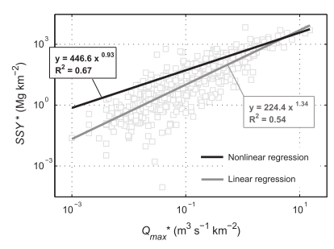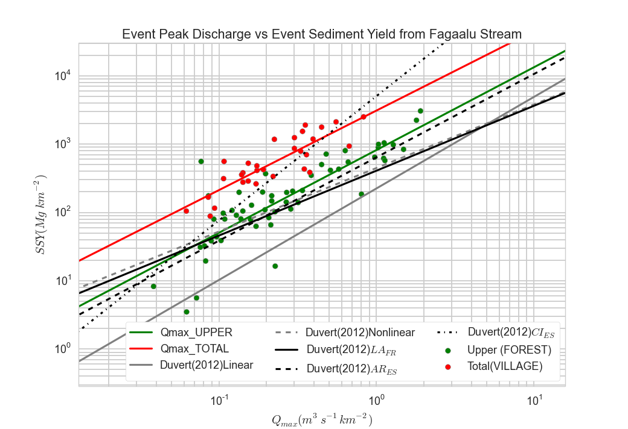

Figure . Power law sediment rating curves for SSY-Qmax from UPPER and TOTAL Faga’alu watersheds.. Linear and nonlinear sediment rating curves for all watersheds in Duvert et al.(2012), as well as three similar watersheds (LAFR ,ARES ,CIES) are plotted for comparison. Inset: All SSY-Qmax data for eight small, mountainous watersheds, fit by linear and nonlinear SSY-Qmax rating curves (Duvert et al., 2012).

The area-normalized SSY-Qmax models for the UPPER and TOTAL watersheds in Faga’alu were compared to the SSY-Qmax models from eight small, mountainous catchments in Spain, France and Mexico (Duvert et al., 2012). The UPPER watershed model was slightly higher, and the TOTAL watershed model was significantly higher than the nonlinear model fit to all the data in Duvert et al. (2012)(Figure 13. The UPPER model was very similar to a watershed specific model (ARES) for a watershed in the Spanish Pyrenees (0.45km2).

Several researchers have attempted to explain the difference in α (intercept) and β (slope) coefficients according to watershed characteristics. A sediment rating curve (Q-SSC) is considered a ‘black box’ model, and the α and β coefficients have no physical meaning. However, some physical interpretation has been ascribed to them, with the α coefficient representing an erosion severity index, and the β coefficient representing the erosive power of the river. High α values suggest high availability of easily eroded sediment sources in the watershed, and high β values suggest that a small change in stream discharge leads to a large increase in sediment load due to the erosive power of the river or the extent that new sediment sources become available as discharge increases (Asselman, 2000).

Similar analysis has been done on event-based sediment yield curves. Rankl (2004) found that β coefficients were not statistically different, and he assumed that the β exponent was a function of rainfall intensity on hillslopes. Rankl (2004) hypothesized that variability in α (the intercept) was a function of sediment availability and erodibility in watersheds, but Duvert et al. (2012) argued that α values are dependent on the regression fitting method (nonlinear method fits higher up on low discharges than linear fit).

The alpha and beta in Faga’alu show that…

# **Conclusions**

Event-based SSY from the UPPER watershed was measured during 55 storms at the upstream site (FOREST), and from the TOTAL watershed during 30 storms at the downstream site (VILLAGE). Given the lack of data on SSY from steep, tropical watersheds, especially for storm events, this research provides novel data for constraining predictions of SSY in these environments, and future comparison to other watersheds adjacent sensitive coral reefs in Puerto Rico and West Maui Priority Watersheds.

SSC was significantly higher downstream of the quarry during base- and stormflows, identifying the quarry as a key source of sediment loading. Changes in the Q-SSC relationship shows a lack of high SSC values in the second and third field campaigns (2013 and 2014), reflecting a change in quarrying practices and significant mitigation of sediment loading during low discharge. A sediment budget quantifying event SSY from the UPPER and LOWER watersheds showed on average 83% of the total sediment loading to the Bay was contributed by the LOWER subwatershed. Sediment loading to Faga’alu has increased ~200% as a result of human land use. Similar to results from other watershed, Qmax had the highest correlation of the tested predictors of SSY, and was best fit by a ordinary least squares regression on the log-transformed data. A model was developed to predict SSY and provide a baseline of sediment loading to Faga’alu Bay from the UPPER, LOWER, and TOTAL Faga’alu watersheds. The area-normalized SSY-Qmax model compared well to other studies, and showed a significant increase in sediment loading above natural levels.

Due to the modeling techniques involving rating curves to model Q and SSC, there needs to be some analysis of the uncertainty in the SSY measurements. Future efforts will include a method for propagating confidence intervals for stage/discharge and turbidity/SSC relationships through to the SSY calculations and sediment rating curves.

# References

Aeby, G., Aletto, S.C., Anderson, P., Carroll, B.P., DiDonato, E.M., DiDonato, G.T., Farmer, V., Fenner, D., Gove, J., Gulick, S., 2006. The State of Coral Reef Ecosystems of American Samoa.

Araujo, H.A., Cooper, A.B., Hassan, M.A., Venditti, J., 2012. Estimating suspended sediment concentrations in areas with limited hydrological data using a mixed‐effects model. Hydrol. Process. 3678–3688. doi:10.1002/hyp.8462

Asselman, N.E.M., 2000. Fitting and interpretation of sediment rating curves. J. Hydrol. 234, 228–248. doi:10.1016/S0022-1694(00)00253-5

Bartley, R., Bainbridge, Z.T., Lewis, S.E., Kroon, F.J., Wilkinson, S.N., Brodie, J.E., Silburn, D.M., 2014. Relating sediment impacts on coral reefs to watershed sources, processes and management: a review. Sci. Total Environ. 468-469, 1138–53. doi:10.1016/j.scitotenv.2013.09.030

Bartley, R., Speirs, W.J., Ellis, T.W., Waters, D.K., 2012. A review of sediment and nutrient concentration data from Australia for use in catchment water quality models. Mar. Pollut. Bull. 65, 101–16. doi:10.1016/j.marpolbul.2011.08.009

Basher, L., Hicks, D., Clapp, B., Hewitt, T., 2011. Sediment yield response to large storm events and forest harvesting, Motueka River, New Zealand. New Zeal. J. Mar. Freshw. Res. 45, 333–356. doi:10.1080/00288330.2011.570350

Bonta, J. V, 2000. Impact of Coal Surface Mining and Reclamation on Suspended Sediment in Three Ohio Watersheds. JAWRA J. Am. Water Resour. Assoc. 36, 869–887.

Buchanan-Banks, J., 1979. The October 28 1979 Landslidng on Tutuila.

Calhoun, R.S., Fletcher, C.H., 1999. Measured and predicted sediment yield from a subtropical , heavy rainfall , steep-sided river basin : Hanalei , Kauai , Hawaiian Islands. Geomorphology 30, 213–226.

Craig, P., 2009. Natural History Guide to American Samoa.

Curtis, S., Wetzell, L., Wiles, P., Tinitali, R., 2011. Turbidity in Faga’alu Stream: The Sources, Impacts, and Solutions.

Dames & Moore, 1981. Hydrologic Investigation of Surface Water for Water Supply and Hydropower.

Draut, A.E., Bothner, M.H., Field, M.E., Reynolds, R.L., Cochran, S.A.Logan, J.B., Storlazzi, C.D., Berg, C.J., 2009. Supply and dispersal of flood sediment from a steep, tropical watershed: Hanalei Bay, Kaua’i, Hawai'i, USA. Geol. Soc. Am. Bull. 121, 574–585. doi:10.1130/B26367.1

Dunne, T., Leopold, L.B., 1978. Water in environmental planning, Other Information: From review by Graham Tobin, Univ. of Iowa, Environ. Prof., Vol.1, No. 4, 261(1978).

Duvert, C., Nord, G., Gratiot, N., Navratil, O., Nadal-Romero, E., Mathys, N., Némery, J., Regüés, D., García-Ruiz, J.M., Gallart, F., Esteves, M., 2012. Towards prediction of suspended sediment yield from peak discharge in small erodible mountainous catchments (0.45–22km2) of France, Mexico and Spain. J. Hydrol. 454-455, 42–55. doi:10.1016/j.jhydrol.2012.05.048

Eyre, P.R., 1994. Ground-water quality reconnaissance, Tutuila, American Samoa. Honolulu, HI.

Fabricius, K.E., 2005. Effects of terrestrial runoff on the ecology of corals and coral reefs: review and synthesis. Mar. Pollut. Bull. 50, 125–46. doi:10.1016/j.marpolbul.2004.11.028

Fahey, B.D., Marden, M., Phillips, C.J., 2003. Sediment yields from a forested and a pasture catchment, coastal Hawkes ba North Island New Zealand.pdf. J. Hydrol. 41.

Galetovic, J.R., Toy, T.J., Foster, G.R., 1998. Guidelines for the Use of the Revised Universal Soil Loss Equation (RUSLE), Version 1.06, on Mined Lands, Construction Sites and Reclaimed Lands. Office of Technical Transfer, Western Regional Coordination Center, Office of Surface Mining.

Gellis, A.C., 2013. Factors influencing storm-generated suspended-sediment concentrations and loads in four basins of contrasting land use, humid-tropical Puerto Rico. Catena 104, 39–57. doi:10.1016/j.catena.2012.10.018

Gippel, C.J., 1995. Potential of turbidity monitoring for measuring the transport of suspended solids in streams. Hydrol. Process. 9, 83–97.

Gray, B.J.R., Glysson, G.D., Turcios, L.M., Schwarz, G.E., 2000. Comparability of Suspended-Sediment Concentration and Total Suspended Solids Data. Reston, Va.

Harmel, R.D., King, K.W., Haggard, B.E., Wren, D.G., Sheridan, J.M., 2006. Practical Guidance for Discharge and Water Quality Data Collections on Small Watersheds. Trans. ASABE 49, 937–948.

Harmel, R.D., Smith, D.R., King, K.W., Slade, R.M., 2009. Estimating storm discharge and water quality data uncertainty: A software tool for monitoring and modeling applications. Environ. Model. Softw. 24, 832–842.

Harrelson, C.C., Rawlins, C.L., Potyondy, J.P., 1994. Stream channel reference sites: an illustrated guide to field technique. USDA Forest Service General Technical Report RM-245. erosion to sediment yield from an urbanizing watershed. US Department of Agriculture, Fort Collins, CO.

Hicks, D.M., 1990. Suspended sediment yields from pasture and exotic forest basins, in: Proceedings of the New-Zealand Hydrological Society Symposium. Auckland, New Zealand.

Horsley-Witten, 2011. American Samoa Erosion and Sediment Control Field Guide.

Horsley-Witten, 2012a. Post-Construction Stormwater Training Memorandum.

Horsley-Witten, 2012b. Post-Construction Stormwater Training Workshop, Field Work, and Interagency Meeting Summary.

Izuka, S.K., 2005. Potential Evapotranspiration on Tutuila , American Samoa.

Kearns, R., 2013. Personal Communication.

Li, Z., Li, P., Lu, K., Zheng, L., Guo, Y., 2004. Development and application of the runoff erosivity for sediment yield prediction on watershed scale., in: Proceedings of the 13th International Soil Conservation Organization (ISCO) Conference. Brisbane, Australia, p. Paper No. 668.

Milliman, J.D., Syvitski, J.P.M., 1992. Geomorphic/tectonic control of sediment discharge to the ocean: the importance of small mountainous rivers. J. Geol. 525–544.

Minella, J.P.G., Merten, G.H., Reichert, J.M., Clarke, R.T., 2008. Estimating suspended sediment concentrations from turbidity measurements and the calibration problem. Hydrol. Process. 22, 1819–1830. doi:10.1002/hyp.6763

Navratil, O., Esteves, M., Legout, C., Gratiot, N., Nemery, J., Willmore, S., Grangeon, T., 2011. Global uncertainty analysis of suspended sediment monitoring using turbidimeter in a small mountainous river catchment. J. Hydrol. 398, 246–259. doi:10.1016/j.jhydrol.2010.12.025

NOAA’s Ocean Service, Coastal Services Center, 2010. 2010 C-CAP Land Cover, Territory of American Samoa, Tutuila.

Pedersen Planning Consultants, 2000. American Samoa Watershed Protection Plan Volume 2: Watersheds 24-35; Prepared for ASEPA.

Presto, M.K., Ogston, A.S., Storlazzi, C.D., Field, M.E., 2006. Temporal and spatial variability in the flow and dispersal of suspended-sediment on a fringing reef flat, Molokai, Hawaii. Estuar. Coast. Shelf Sci. 67, 67–81. doi:10.1016/j.ecss.2005.10.015

Rankl, J.G., 2004. Relations Between Total-Sediment Load and Peak Discharge for Rainstorm Runoff on Five Ephemeral Streams in Wyoming.

Slaymaker, O., 2003. The sediment budget as conceptual framework and management tool. Hydrobiologia 494, 71–82.

Sprugel, D.G., 1983. Correcting for bias in log-transformed equations. Ecology 64, 209–210.

Syvitski, J.P.M., Vörösmarty, C.J., Kettner, A.J., Green, P., 2005. Impact of humans on the flux of terrestrial sediment to the global coastal ocean. Science (80-. ). 308, 376–380.

Tonkin & Taylor International Ltd., 1989. Hydropower feasibility studies interim report phase 1.pdf.

Tuitele-Lewis, J., 2004. Agroforestry in American Samoa. Oregon State University.

Turnipseed, D.P., Sauer, V.B., 2010. Discharge Measurements at Gaging Stations. Reston, Va.

URS Company, 1978. American Samoa Water Resources Study: Assessment of Water Systems American Samoa. Coastal Zone Information Center, Honolulu, HI.

US Bureau of Reclamation, 2012. The WinFlume Homepage [WWW Document]. URL http://www.usbr.gov/pmts/hydraulics_lab/winflume/

Walling, D.E., 1977. Assessing the accuracy of suspended sediment rating curves for a small basin. Water Resour. Res. 13, 531–538.

Warrick, J. a., Mertes, L. a. K., 2009. Sediment yield from the tectonically active semiarid Western Transverse Ranges of California. Geol. Soc. Am. Bull. 121, 1054–1070. doi:10.1130/B26452.1

Wong, M., 1996. Analysis of Streamflow Characteristics for Streams on the Island of Tutuila, American Samoa.

Zimmermann, A., Francke, T., Elsenbeer, H., 2012. Forests and erosion: Insights from a study of suspended-sediment dynamics in an overland flow-prone rainforest catchment. J. Hydrol. 170–181.